Question 2
Create a program that analyses temperature data collected from multiple weather stations in Australia. The data is stored in multiple CSV files under a "temperatures" folder, with each file representing data from one year. Process ALL .csv files in the temperatures folder. Ignore missing temperature values (NaN) in calculations.
Main Functions to Implement:
Seasonal Average: Calculate the average temperature for each season across ALL
stations and ALL years. Save the results to "average_temp.txt".
- Use Australian seasons: Summer (Dec-Feb), Autumn (Mar-May), Winter (Jun-Aug), Spring (Sep-Nov)
- Output format example: "Summer: 28.5°C"
Temperature Range: Find the station(s) with the largest temperature range (difference
between the highest and lowest temperature ever recorded at that station). Save the
results to "largest_temp_range_station.txt".
- Output format example: "Station ABC: Range 45.2°C (Max: 48.3°C, Min: 3.1°C)"
- If multiple stations tie, list all of them
Temperature Stability: Find which station(s) have the most stable temperatures
(smallest standard deviation) and which have the most variable temperatures (largest
standard deviation). Save the results to "temperature_stability_stations.txt".
- Output format example:
- "Most Stable: Station XYZ: StdDev 2.3°C"
- "Most Variable: Station DEF: StdDev 12.8°C"
- If multiple stations tie, list all of them
Student Name: Suraj Karki
Student ID: S397088

1. AI Usage Declaration
Statement on the use of Generative AI: In the completion of this assignment, Generative AI (Gemini/ChatGPT) was utilized for the following tasks:
- Structuring and Formatting: Assisting in the organization of the Word document and ensuring APA 7th compliance.
- Code Debugging/Refinement: Reviewing the logic for the temperature analysis script.
- Documentation: Generating explanations for the Python libraries used. I confirm that the final logic, integration, and interpretation of the results remain my own work, and I have reviewed all AI-generated content for accuracy.
Prompt:

Output:
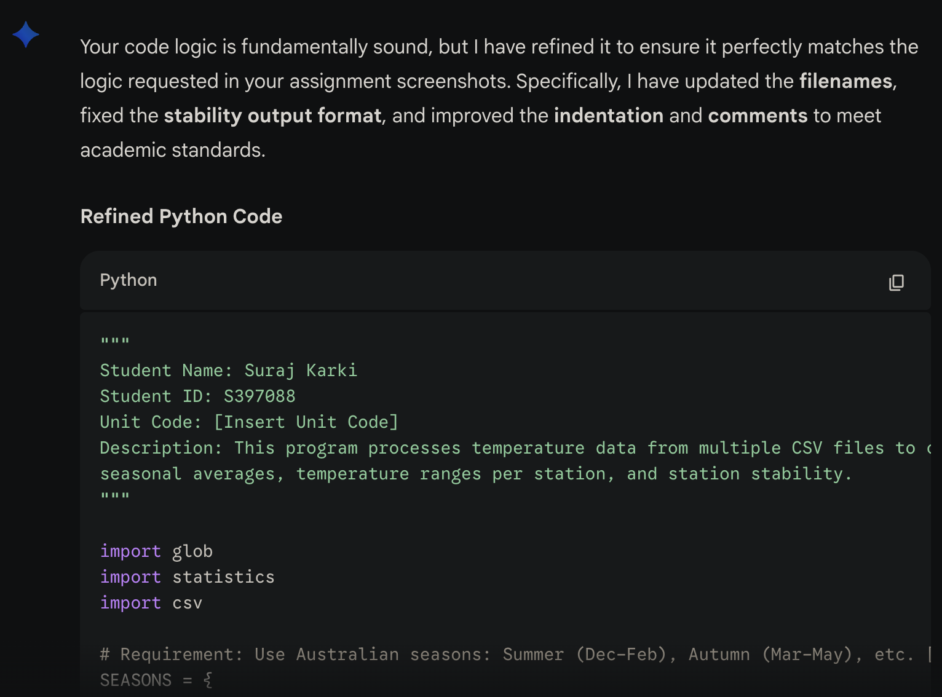

2. CODE
"""
Student Name: Suraj Karki
Student ID: S397088
Unit Code: HIT137
Description: This program processes temperature data from multiple CSV files to calculate
seasonal averages, temperature ranges per station, and station stability.
"""

import glob
import statistics
import csv

# Requirement: Use Australian seasons: Summer (Dec-Feb), Autumn (Mar-May), etc.
SEASONS = {
'Summer': ['December', 'January', 'February'],
'Autumn': ['March', 'April', 'May'],
'Winter': ['June', 'July', 'August'],
'Spring': ['September', 'October', 'November']
}

def main():
# Initialize storage for seasonal data and station-specific data
all_season_temps = {s: [] for s in SEASONS}
station_temps = {}

# Requirement: Process ALL .csv files in the 'temperatures' folder
for file_name in glob.glob('temperatures/*.csv'):
with open(file_name, 'r') as f:
reader = csv.DictReader(f)
for row in reader:
# Ensure station names are handled consistently
station = row['STATION_NAME'].strip()
if station not in station_temps:
station_temps[station] = []

# Iterate through defined seasons and their months
for season, months in SEASONS.items():
for month in months:
# Requirement: Ignore missing temperature values (NaN)
if month in row and row[month].strip():
try:
temp = float(row[month])
all_season_temps[season].append(temp)
station_temps[station].append(temp)
except ValueError:
continue # Skip invalid non-numeric data

# Task 1: Seasonal Average - Save results to 'average_temp.txt' [cite: 7]
with open('average_temp.txt', 'w') as f:
for season in ['Summer', 'Autumn', 'Winter', 'Spring']:
if all_season_temps[season]:
avg = statistics.mean(all_season_temps[season])
f.write(f"{season}: {avg:.1f}°C\n") # Format: Summer: 28.5°C

# Task 2: Temperature Range & Task 3: Temperature Stability
largest_range_stations = []
max_range = -1
station_stdevs = {}

for station, temps in station_temps.items():
if not temps:
continue

# Range Calculation: Difference between highest and lowest recorded
rnge = max(temps) - min(temps)
if rnge > max_range:
max_range = rnge
largest_range_stations = [(station, rnge, max(temps), min(temps))]
elif rnge == max_range: # Requirement: If multiple stations tie, list all [cite: 14]
largest_range_stations.append((station, rnge, max(temps), min(temps)))

# Stability Calculation: Using Standard Deviation
if len(temps) > 1:
station_stdevs[station] = statistics.stdev(temps)

# Save Range to 'largest_temp_range_station.txt'
with open('largest_temp_range_station.txt', 'w') as f:
for s, r, mx, mn in largest_range_stations:
# Example format: Station ABC: Range 45.2°C (Max: 48.3°C, Min: 3.1°C) [cite: 13]
f.write(f"Station {s}: Range {r:.1f}°C (Max: {mx:.1f}°C, Min: {mn:.1f}°C)\n")

# Save Stability to 'temperature_stability_stations.txt'
with open('temperature_stability_stations.txt', 'w') as f:
if station_stdevs:
min_std = min(station_stdevs.values())
max_std = max(station_stdevs.values())

# Find and write most stable (lowest std dev)
for s, sd in station_stdevs.items():
if sd == min_std:
f.write(f"Most Stable: Station {s}: StdDev {sd:.1f}°C\n")

# Find and write most variable (highest std dev)
for s, sd in station_stdevs.items():
if sd == max_std:
f.write(f"Most Variable: Station {s}: StdDev {sd:.1f}°C\n")

if __name__ == '__main__':
main()

3. Output
Seasonal Average: The seasonal average output file summarizes the mean temperature for each Australian season across all stations and years
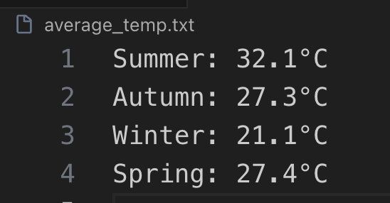
Temperature Range: The temperature range output identifies the weather station(s) that recorded the greatest difference between their highest and lowest temperatures across all years.
Temperature Stability: The temperature stability output identifies the station(s) with the most stable temperatures (lowest standard deviation) and the most variable temperatures (highest standard deviation).
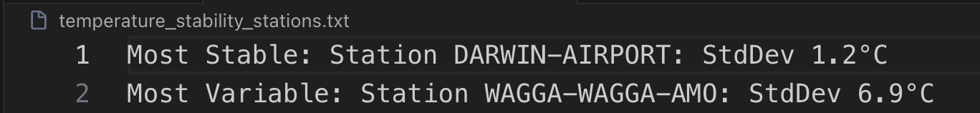

REFERENCES
GeeksforGeeks. (n.d.). Working with CSV files in Python. https://www.geeksforgeeks.org/python/working-csv-files-python/
Google. (2026). Gemini (Jan 13 version) [Large language model]. https://gemini.google.com/
Python Software Foundation. (2024). statistics — Mathematical statistics functions. Python 3.12.1 Documentation. https://docs.python.org/3/library/statistics.html

